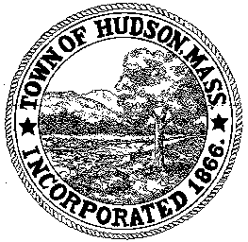

BOARD OF HEALTH
78 Main Street
Hudson, MA 01749
(978) 562-2020
Meeting Agenda
October 30, 2012
7:00 PM

- Preliminaries
1.1 Open Meeting
1.2 Roll Call

2.0 General Business
2.1 Minutes – October 9, 2012
2.2 Voucher – BOH101612 $6494
Voucher – BOH101712 $3120
Voucher – BOH102312 $834.50
Voucher - BOH 103012 $183.20
2.3 Tobacco Control District
2.4 Disaster Animal Response Team
2.5 FY ’14 Budget
2.6 Transfer Station Complaints

3.0 Review Installer Applications:
3.1 Austin Excavating

4.0 Adjournment

Next Meeting: November 13, 2012

